INS3121
SOIL MECHANICS
MAKE UP EXAM
December 29th, 2016
Q.1 | Q.2 | Q.3 | Q.4 | Q.5 | TOTAL
Student name Surname:
Number:
Group:

- An excavation will be made in the soil profile shown in the below figure. The permeable soil layer underlying the clay was observed to be under artesian pressure. If the water in the drill hole rose to a height of 7 m above the permeable layer,

- How deep (H) can the excavation proceed before the bottom heaves?
- Compute the factor of safety against heaving if the excavation reaches a depth of H=10 m.
- Compute the elevation head, pressure head and total head at the point of A by considering the top of permeable soil layer as reference level.

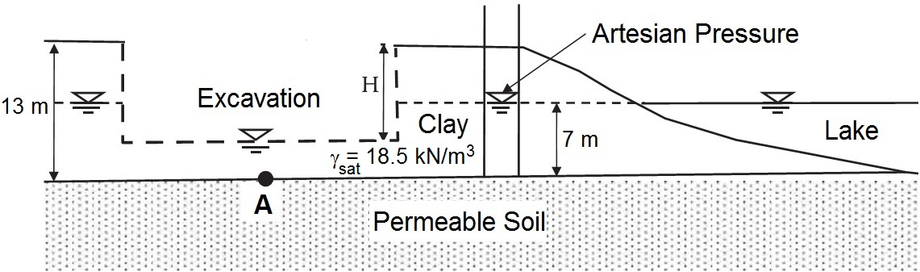

- The flow-net for the water seepage below a sheet pile wall is given below. The hydraulic conductivity (permeability) of the soil is determined to be k=4x10⁻⁶ cm/sec. According to the given information,
- Calculate the amount of water seepage under the sheet pile wall.
- Calculate the total hydraulic head and water pressure at points A, B, and, C.

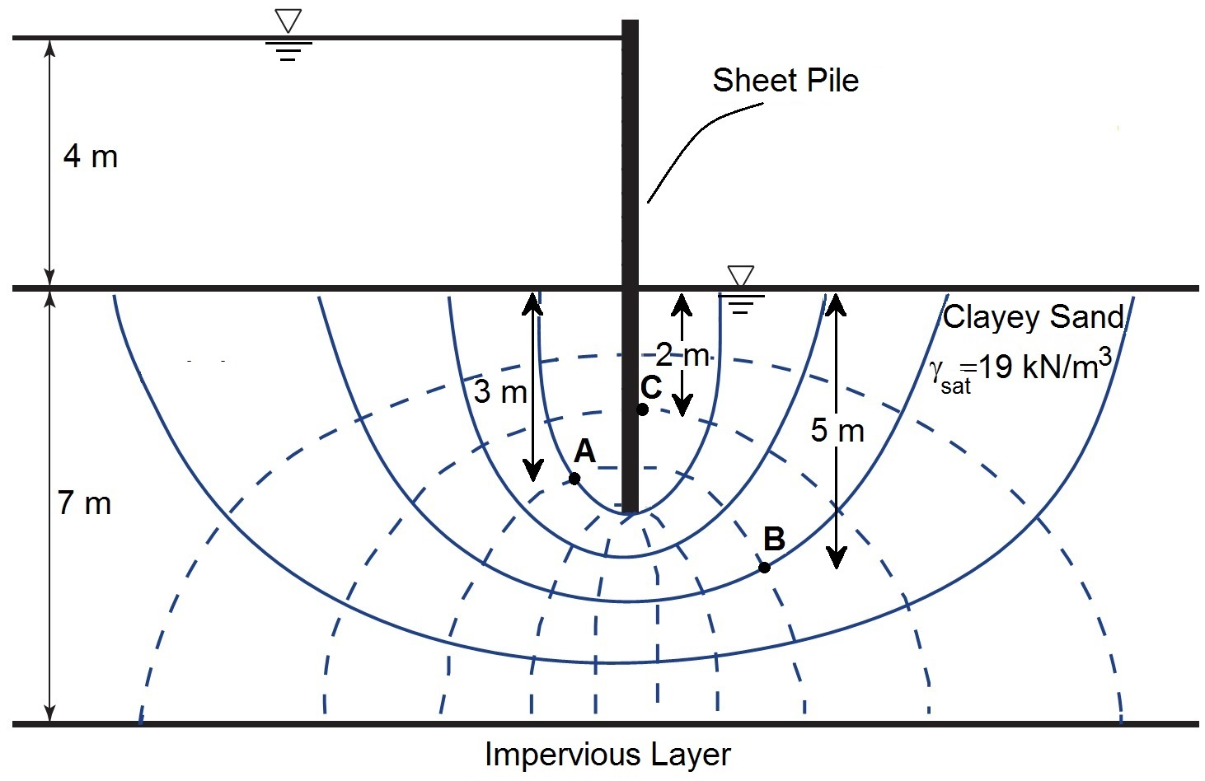

- A square (10m x 10m) mat foundation having 2 m thickness will be constructed on a 12 m thick normally consolidated clay layer overlying an impervious layer. The ground water level is at the top of the clay later (γ_{w}=9.81 kN/m³). The clayey soil has following properties; initial void ratio (e_{o}) is 1.20, compression index (C_{c}) is 0.15, consolidation coefficient (c_{v}) is 0,0008 cm²/sn and specific gravity of solids (Gs) is 2.67 (Take Concrete unit weight as 25 kN/m³)

  - Calculate the total settlement of the clay layer (Determine the stress increment due to mat foundation using 2:1 Method)
  - Compute the time required for 80% consolidation settlement to take place in the field.

U (%) | 10 | 20 | 30 | 40 | 50 | 60 | 70 | 80 | 90
T_{v} | 0.008 | 0.031 | 0.071 | 0.126 | 0.197 | 0.287 | 0.408 | 0.567 | 0.848

- A series of triaxial tests were carried out on undisturbed over consolidated clay samples and the test results are as follows:
Test | Cell Pressure (kPa) | Deviatoric Stress (kPa)
First CD Test | 120 | 185
Second CD Test | 240 | 330

a) Find the drained shear strength parameters of the clay soil.
b) Compute the angle that failure plane makes with respect to horizontal (α_{f}).
c) Draw the Mohr Circle for the tests and the failure envelope for the clay soil.

- An excavation was made in a borrow area that have a void ratio of 1.08 and specific gravity (Gs) of 2.65. The excavated soil was transported to fill area and compacted. The water content of the borrow area is determined to be %12. There has been no water loss during transportation and a volume of 16500 m³ water was added in the fill during compaction. The void ratio of the fill is determined to be 0.68.

a) If the excavated soil from borrow area is 145000 m³, calculate the volume of the produced earthfill.
b) Maximum dry unit weight and optimum water content were determined from laboratory compaction test as γ_{maks}.= 18 kN/m³ and w_{opt}= %19.5, respectively. Check if the compaction in the field meets 85% relative compaction and w_{opt} ±2% criteria.

Group 2: Prof. Dr. Suat Akbulut
Group 3: Assoc. Prof. Dr. Şükrü Özçoban
Group 4: Assoc. Prof. Dr. Havvanur Kılıç
Group 5: Assoc . Prof. Dr. Pelin Özener
Group 6: Asst. Prof. Dr. Nejat N. Çetinkaya

Time is 90 minutes. Good Luck.

